Kickstarter campaigns – Report

1. Conclusions:
2. The number of successful campaigns has decreased dramatically.

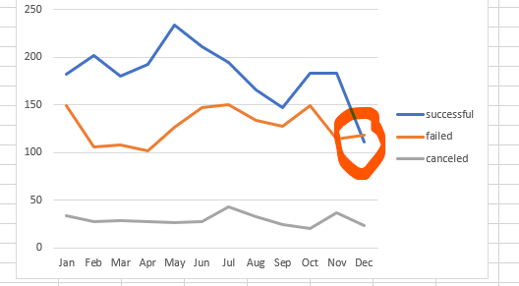

1. Theater is the most common category of campaigns and the most successful one with Plays as the most common subcategory.

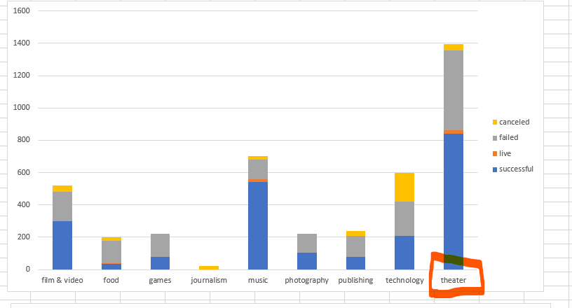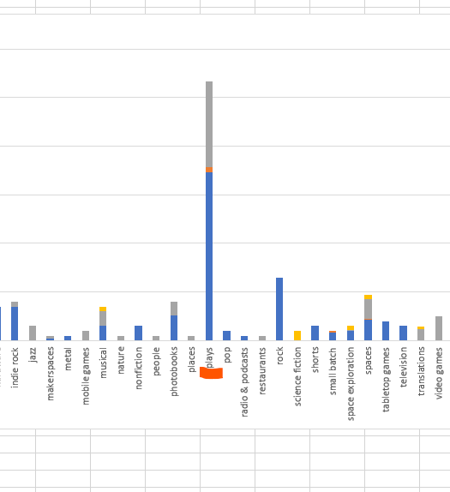

1. Apparently, most of the successful campaigns were created between March and April.

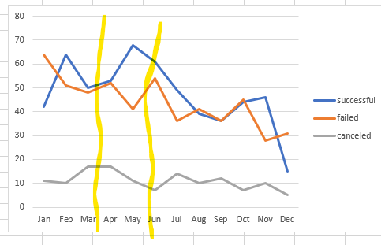

2.-

The data is not updated the last year shown is the 1st trimester of 2017 and not sure if the number of projects selected helps to understand the overall picture of Kickstart's behavior.

The data set required some adjustments to be useful (\*which is the most common scenario)

3.-

-A missing analysis that can be done is including the country so we can analyze campaigns by its origin country.

-With time created and time ended we can analyze the average time for a campaign whether by status or category.

-We can also add a visualization to see more clearly the average money collected by the campaign category and how many backers did they gather.